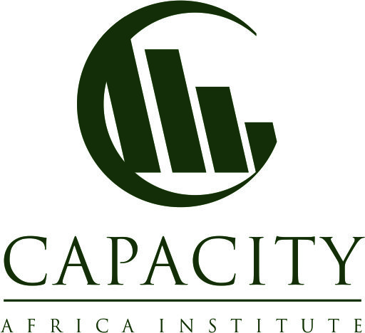

Student: Pindurai Makufa. Course: Post Graduate Diploma Water and Sanitation Hygiene November 2019.

WASH SIGNMENT:

1. Week 4 Assignment
- Suppose you work with a community radio station, describe what your radio station would do to address water, sanitation and hygiene issues with regard to your i) audience, and ii) WASH messages?

WATERAID & WSSCC 2003 suggests that radio plays an important role in building up people’s motivation and direct to their hearts. People listen to the radio as a group, enhance discussion and enjoy oral traditions (stories) and songs. (BURKE 1999). WaterAID, 2007 suggests that community radio encourages participation and opinion sharing, improving and diversifying knowledge and skills and in catering to health and cultural needs (WATERAID 2007). Most community radios are not-for- profit and provide the vehicle for individuals, groups and communities their own lives and share experiences. Community is viewed as a group of people living in the same locality and share common practices. Community radio has been built around the ideals of access and participation. Stations have been run by locals, typically to serve a local audience. (BBC, 2014- 2017).


The community radio plays an important role in raising awareness on water and sanitation to change public opinion and behaviour on an issue and a tool for advocacy (WATERAID & WSSCC 2003). A community radio reaches a wider audience than any other medium (BURKE 1999). And radio campaigns are a cheap method to spread information about water-related projects widely (WATERAID & WSSCC 2003). Radio reaches a very wide audience and main actors generally come from the local level. Radio campaigns reach a wider audience than any other medium, and are accessible to people who are otherwise isolated by geography, conflict, illiteracy or poverty (WATERAID & WSSCC 2003). This will influence people’s attitude and behaviour (WATERAID 2007).
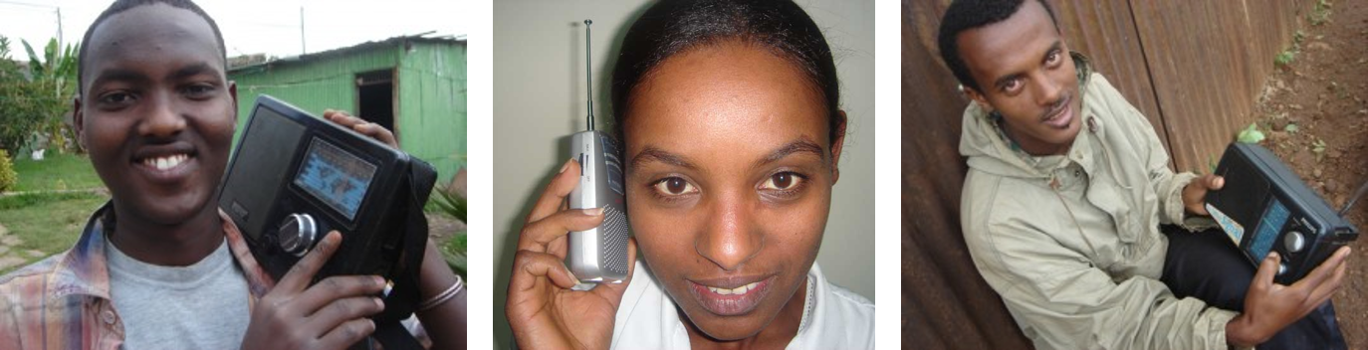
Radio - a medium that can be used almost anywhere nowadays. Source: RADIO FOR DEVELOPMENT (2010)
In choosing the audience, the following has to be taken into consideration when planning a community radio campaign (adapted from FOCUS 2006): The first step would be defined audience that is the public/community or population for which the message is intended. Depending on the composition of the community these messages have to be deliberate, basic and memorable. The level of the community is important to take into consideration. It is important to consider the religious background of the location before planning a community radio audience since this is likely to infringe on the religious values of the people but not to break the any religious rites. It is important that resources be taken into consideration to ascertain that the audience will be reached. It is important to carry out a stakeholder’s analysis through feasibility studies to be able to know the audience or the community so that I select the effective messages and channels of communication and take into account the socio cultural issues. This will be used as the basis for setting objectives, goals and milestones. The level of participation is of essence in this regard. Burke, 1999 suggests that community radio can target poorer people and interviews, phone –ins, letters and recording of outside events, involve them in developing the content of the messages and this makes the messages/programmes relevant for the people/community. By so doing the community radio organized this way will make the local people’s voices heard and reach people with messages, for example sound bites or break – bumpers like: “Did you wash your hands today?”
While it is laudable to suggest that community radio is an effective way to communicate WASH messages to selected, specific audiences, it has also been criticized as it is one-way medium since people are not able to listen again or request that it be repeated again. At the same time, some people do not have access to radios, electricity or battery cells to power the radios. Letter questions means the turnaround time takes a lot of time.
WASH messages can be conveyed (the content) on the community/audience in the following categories:
Sanitation (Adapted from BBC Action, 2014-2017)
They are:
Personal hygiene- Regular hand and arm washing and covering cuts;
Cleaning and sanitisation of all food contacts dishes and surfaces, including utensils
Good basic housekeeping and maintenance; and food storage.
Improvement of sanitation (Adapted from BBC Action, 2014-2017)
- Flushing of toilets and connection to a piped sewer system.
- Flush / pour-flush to a pit latrine.
- Pit latrine with slab.
- Ventilated improved pit latrine (abbreviated as VIP latrine)
- Composting toilet.
Methods of sanitation? (Adapted from BBC Action, 2014-2017)
- These methods will include sensatization on processes of disposing of waste properly, so it does not threaten the environment or public health. The four types are: filtration, landfills, recycling and ecological.
Messages on Components of personal hygiene (Adapted from BBC Action, 2014-2017)
Body hygiene (skin care)
Oral hygiene (oral care)
Hand washing (hand care)...
Face hygiene. ...
Fingernail and toenail hygiene (nail care)...
Ear hygiene. ...
Hair hygiene (hair care) ...
Foot hygiene (foot care)
The audience will be outreached on the five domains of hygiene? (Adapted from BBC Action, 2014-2017)
Five behavioural domains
- Disposal of human faeces.
- Use and protection of water sources.
- Water and personal hygiene.
- Food hygiene.
- Domestic and environmental hygiene.
- What are the advantages of the radio?
For these messages to be effective, it important that, the messages have the right content or themes, the tone of the messages has to be moderated and the right appeal and whether there is humour or fear. The chosen messages have to pass the test of questions like: ‘’what? So What? Now What?’ Test:
In the end there will be need for evaluation of the effectiveness of the community radio and the messages on the selected audiences.

2.In your own words, what is your understanding of public health and what are its key elements?

What is the Definition of Public Health?
Public health is a scientific study which is aimed at prevention and protection for purposes of safety and improvement the health of the communities by providing health promotion education, influencing policy making safeguarding the health of populations, carrying out research on diseases and injury prevention. (American Public Health Association, 2019).
On the other hand public can be viewed as that aspect of approaching from the point of view research in laboratories and in the field on whole or selected populations to prevent them from contracting diseases and by improving their health with a view to shape or influence health policy (CDC,2017)
Borrowing from CDC, 2017 public health can be defined as a science and the art of preventing populations and whole communities from getting diseases, extend people’s lives and promotion of people’s health by allowing societies to make informed choices through organized efforts, organizations, public and private, communities and individuals. Public health involves carrying out community impact assessments on the health of whole or part populations and possible health through surveillance and develop health policies. Public health approaches help to prevent the spread of epidemics and spread of diseases, and injuries, promotion and encouragement of safe health social behaviours, protection against environmental hazards and on how to respond to disasters and assist communities to recover as shown in the diagram below:

The 10 Essential Public Health Services

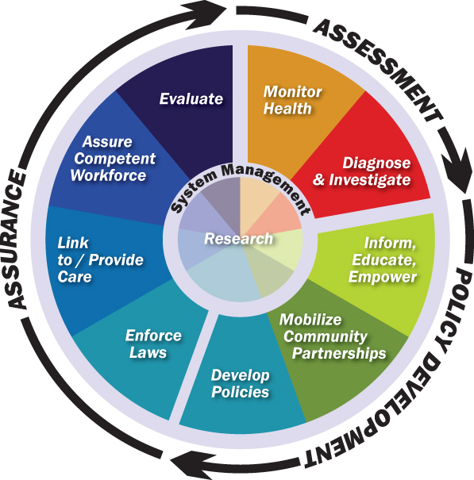

CDC, 2017

Week 2 Assignment
- Public health is about partnership between the different players. In a paragraph each, explain how the role of international non-profit/NGO in terms of i) recruitment ii) training iii) funding and iv) monitoring for public health projects contribute to the success or failure of those projects in the developing countries?
Non-governmental organizations (NGOs) have played an important role as an alternative service provider vis-à-vis the state, especially in the developing countries where there are shoe string budgets attached to health provision and financing preferring defence, perpetuation of government inefficiencies and inadequacies, corruption and both material and human resource constraint. (Gilson L, Sen PD, Mohammed S, Mujinja P. 2014).Public health initiatives have to be led by government as is the case in developed countries e.g. United Kingdom – Public Health England and charities / NGOs come in to complement or support government efforts in meaningful efforts and some of the NGOs are funded from the fiscus. The essence of working in partnership is crucial, hence the recruitment. However, in Africa, this public private partnership in health provision in reality is more complex, moreso in their recruitment. In the recruitment of NGOs consideration has to be given to the distinction between government and NGO providers since it can be difficult to determine the operational integration. While in the developing countries the assumption which is a misconception that NGOs have it all, including international ones have it all, a case to consider when thinking about recruitment is resources and capacity, hence suffer from resource constraints and management deficiencies. In this regard and coupled with government inefficiencies and beaurocracy, some NGOs fail to fulfill project obligations. When considering recruitment of NGOs, especially international organizations and occasionally operate as for-profit providers in practice for purposes of sustainability. The downsize of this is that, in the public private partnership, the beneficiaries will end up paying for the service and the majority of them cannot afford, hence loss of service. (Gilson L, Sen PD, Mohammed S, Mujinja P.2014). Although most NGOs regard themselves as not for profit concentrating on humanitarian principles, they end up maximizing on the same proselytizing their faith to be their first concern be they: religious, international, locally-based, unions and trade and professional associations, other nonprofit organizations such as occupational health services, and their focus being: service provision, social welfare activities, support activities, and research and advocacy.
In all of these roles, they make an important contribution to health care. Effective policy development by Governments will reveal the strengths and weaknesses of NGOs in relation to settings vis-à-vis the potential of resource mobilization. It is Government responsibility to co-ordinate and regulates health care provision and the NGOs have to be in compliance for the government to be able to meet its set goals- Reality check for NGOs. Regulation is important because International NGOs relate to their parent organisation International NGO support also has its own problems: it is often project-specific, available for limited periods, and usually limited to start-up costs.e.g. United Nations Development Programme.
In conclusion, whatever strategies the Government put in place in the selection of cooperating International organizations on issues of medical care provision, it should have strong policy development which indicate strengths and weaknesses and flexibility style of operation so that they carry out their function within national policy guidelines.

3.In your capacity as the environmental health officer you have been tasked to lead the assessment of a disaster situation. Come up with two key questions under each of the following five headings in your assessment list , namely i) General overview of the situation ii)Water supply iii) Solid-waste disposal iv) Excreta disposal and v) Vector-borne diseases for purposes of assessing local conditions, health needs and identifying local resources in the disaster situation that you are addressing.

4.As an Environmental Health Officer Communications during assessment disaster situation is critical. On the following sub topics in carrying out the above mentioned task I will ask the following questions:
General overview of the situation:
It’s worth considering having alternate means of communications until the organization’s infrastructure is operational. If you’re going to use conference call bridges, then certain information needs to be available to everyone prior now.(Bourne, 2014) This information includes the following:
- What is a disaster situation communication system vis-à-vis disaster linkages?
- What is documentation system for people and livelihoods affected and the framework for decision-making in relation to disaster situation?
- What is the specification of possibly conflicting situations as they relate to the disaster situation?

ii. Water supply

What are the extreme weather events that affect the operation of water supply, drainage and sewerage infrastructure?

What are the integrated environmental and health approaches that address cross-cutting issues and the functioning of wastewater treatment plants?

iii. Solid-waste disposal

What are the waste management facilities are in and proximity to the disaster situation area in relation to solid waste?

What are the local capacities for addressing disaster waste gaps/needs for additional assistance?

iv. Excreta disposal
What are the methods of excreta disposal?
What are the methods/types of latrines used in sanitation?
- v. Vector-borne diseases for purposes of assessing local conditions, health needs and identifying local resources in the disaster situation that you are addressing.
What is the relationship between communicable/vector – bourne diseases as regards the disaster situation?
What are the prevailing natural events e.g. heavy rain falls may aid the transmission of vector – borne diseases?

References
BURKE, A. (1999): Communications & Development. A practical guide. London: Social Development Division. Department for International Development. URL [Online: Accessed: 19.10.2019].

Centers for Disease Control. 2017: "What is Public Health"? Centers for Disease Control Foundation. Atlanta, GA: [Online: Accessed. 20 October 2019.]
FOCUS (Editor) (2006): Community Based Media Campaign Action Pack. Kingston: Ontario Stroke Strategy. URL [Online: Accessed: 25.11.2019].
Gilson L, Sen PD, Mohammed S, Mujinja P. 2014 .The potential of health sector non-governmental organizations: policy options. London School of Hygiene and Tropical Medicine, UK.

https://www.bbc.co.uk/mediaaction/where-we-work/africa/kenya/wash: BBC Action, 2014-2017: Using radio to address sanitation and hygiene in Kenya [Online: Accessed: 26.11.2019]
Kelly C. Bourne,K.C., 2014. in Application Administrators Handbook,
SCHAAP, W.; STEENBERGEN, F. van (2001): Ideas for Water Awareness Campaigns. Stockholm: The Global Water Partnership. URL [Online: Accessed: 25.11.2019].
WATERAID & WSSCC (Editor) (2003): Advocacy Sourcebook. A Guide to Advocacy for WSSCC co-ordinators working on the WASH campaign. WATERAID & WSSCC . URL [Online: Accessed: 10.11.2019].
WATERAID (Editor) (2007): The Advocacy Sourcebook. London: WaterAid. URL [Online: Accessed: 15.11.2019].
WHO (Editor) (2008): Celebrating World Water Day 2008. An Advocacy Guide. URL [Online: Accessed: 19.10.2019].

